

**FUNCTIONAL REQUIREMENTS**

Product Name: Sarasavi Online bookstore (Frontend)

Prepared by: Raveen Jayasooriya

Date: Feb 11, 2023

Overveiw

Sarasavi.lk is a website for an extensive collection of books, stationery and magazines. Not only a “one-stop shop” for book lovers but also an interactive and innovative destination designed to make it fun and exciting to discover and shop for new books and gifts online. Buy books online and get them delivered right to your door, Sri Lanka's Premier Online Bookseller Sarasavi Bookshop [www.sarasavi.lk](http://www.sarasavi.lk)

Requirements

Online Bookseller Sarasavi Bookshop requires certain technical requirements to be met for the store to operate properly. First , a web server must be created to make online bookstore publicity available on the web.

These extensions must be enables for Sarasavi online bookstore to install prpperly on the web server.

* Apache 2.2.15
* HTML5 Shiv
* Rollbar
* JavaScript Frameworks
* Head JS
* Google Font API
* Mousewheel JS

Sarasavi online bookstore Frontend

This Document is intended to be uses as an introduction to the Sarasavi online bookstore default store front. The store front reveals how the customer view and interacts with the store.

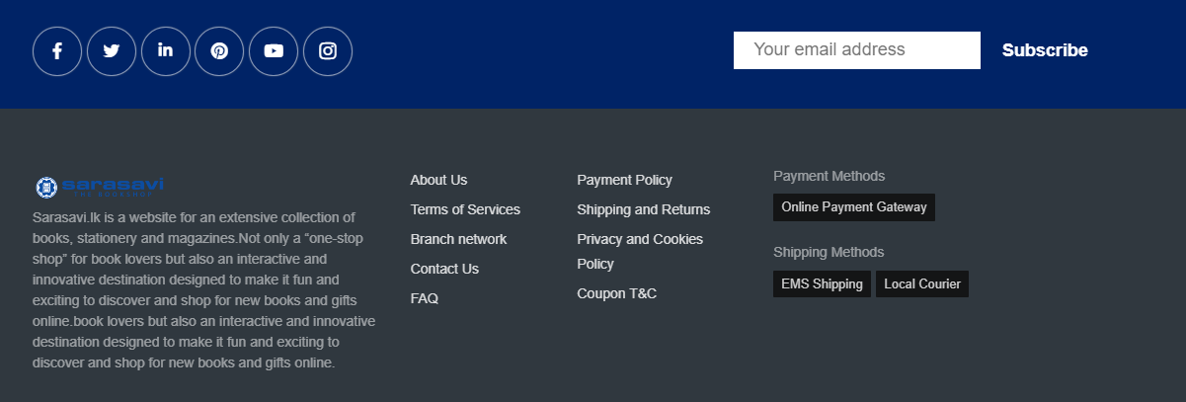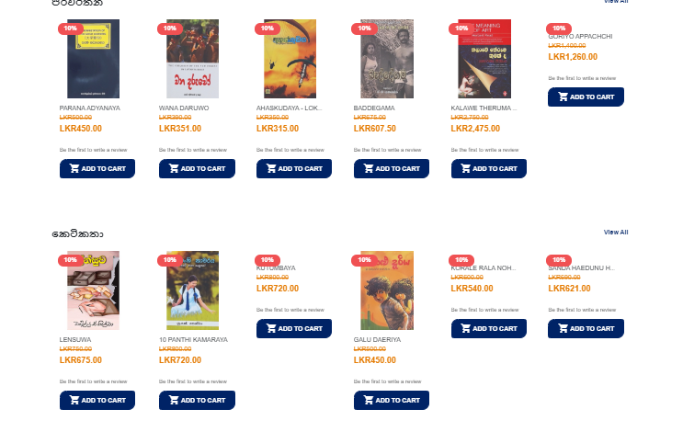

The Product seen above are include as sample daat with the Online bookstore Installation.These Products can easily be removed and replaced with the shop’s prdouct later.

**Navigating the shop**

The Online bookstore default theme makes navigating shop’s products easily accessible to its customers.

**Home Page**

A home page) is the main web page of a website. The term may also refer to the start page shown in a web browser when the application first opens. Usually, the home page is located at the root of the website's domain or subdomain. For example, if the domain is https://www.sarasavi.lk/, the home page is likely located at <https://www.sarasavi.lk/>.

**The header**

The header will be displayed at the top of the page ,on every page of the store ;not just the home page.

The header has the following navigation options:

* Store Logo : Clicking on this logo will direct the customer back to the home page of the store.
* Shoping Cart : Displays the number of items purchased , and the total price of the order .Clicking on the button will containing all of products added to the cart and an options to “View Cart” or “Checkout”
* Search Box : The customer can type in search box to search for a product within the store’s product categories.
* Wishlist : Customer can create a personalized collection of products they want to buy in the future and save them in their user account for future reference.

**The top menu**

The top menu category only displays the top parent categories of products.

Like the header, the top menu will be displayed on every page. When the customer’s mouse is dragged over “Shop by category”, a drop – down menu will display the sub- categories for that parent category.

When Shop by category is clicked, the customer will be directed to the category page, which displays all the products within that category.

**Slideshow**

The slideshow displays several products banners of your choice by alternating the images in a slideshow. After a certain amount of time, one banner will shift to the next banner. Banners in this slideshow are useful for highlighting certain products to be easily accessible by the customer. When the banner is clicked on, the customer will be directed to the product on the banner’s page.

**New products**

The Online bookstore gives you’re the options of featuring specific products of their choosing on the home page

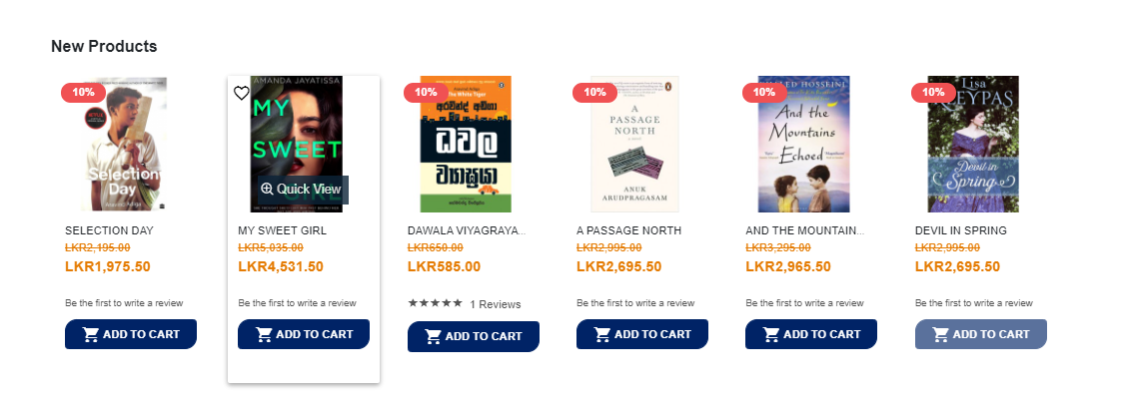

The New Products section includes the products image, name, price and an options to add the product directly to the Shopping Cart.

**Footer**

The footer is located at the bottom of every page, not just the Home page.This block f miscellaneous links is useful in sorting relevant pages for the customer that may not logically sort anywhere else.

The organizational scheme of the footer can be divided into the following sections :

* About US
* Terms of services
* Branch Network
* Contact Us
* FAQ Payment policy
* Shipping and returns
* Privacy and Cookies Policy
* Coupon T&C
* Payment Methods
* Shipping Methods